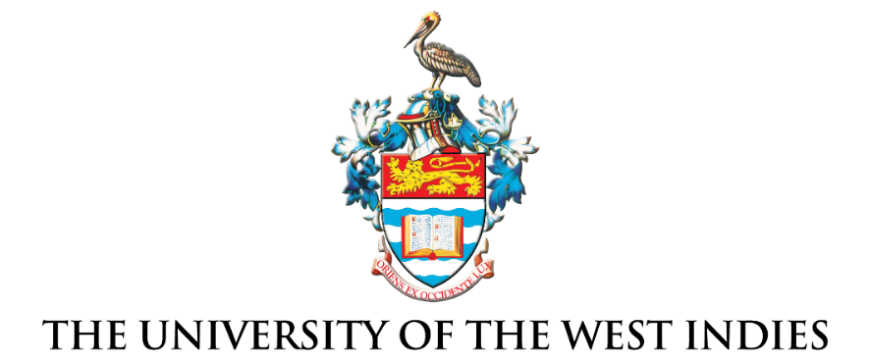

Media release
For further information, please contact the University Marketing and Communications Office
via email at universitymktgcomms@sta.uwi.edu
-----------------------------------------------------------------------------------------------------------------------------------------------
For Immediate Release

AI and ChatGPT in Higher Education –
Students need guardrails not bans

The UWI Regional Headquarters, Jamaica W.I. Saturday, May 20, 2023 — With the eruption of Artificial Intelligence (AI) tools like ChatGPT higher education experts are concerned about where these tools fit in the academic space. The University of the West Indies’ virtual Vice-Chancellor’s Forum on Artificial Intelligence (AI): A Blessing or Curse for Higher Education held on May 9, 2023, placed education experts on a panel to discuss the unfolding issues.

At the discussion table were Professor C. Justin Robinson, Pro Vice-Chancellor, Board for Undergraduate Studies, The UWI; Dr. Emma Sabzalieva, Head of Research and Foresight, UNESCO International Institute for Higher Education in Latin America and the Caribbean (IESALC); Ms. Arianna Valentini, Research and Foresight, UNESCO IESALCA; Dr. Margaret Niles, Manager, Research Insights and Products Innovation, Caribbean Examinations Council (CXC); and Ms. Patti West-Smith, Director, Customer Engagement Team, Turnitin.

Professor Robinson, moderator for the forum, opened the session introducing the topic on behalf of Vice-Chancellor, Professor Sir Hilary Beckles and showcased the ability of ChatGPT using the trial version to write a poem based on keywords. Panellists then jumped into the topic discussing whether AI was a blessing or curse for higher education. The consensus was that AI is neither. It now provides the opportunity to “improve the quality of work for educators and meaningfully impact the learning outcomes for students” said Ms. Patti West-Smith – the panellists agreed. The panel also cautioned that AI tools are dependent on information produced by others in order to create and as such are inherently biased. Building on the point, panellist Ms. Arianna Valentini gave the example of gender bias, stating “if you asked ChatGPT to give you a list of 10 modern philosophers, it will most likely give you a list of male philosophers coming from the west.”

The panel also discussed the extreme option of banning AI from higher education on the grounds that the tools could constitute cheating and encourage unoriginal thinking. The experts were unified in their position that with the technology already in use and likely to continue, the idea of banning AI tools likely comes from a place of fear. They believe it should instead be used strategically to empower students to think originally and critically. Panellist Patti West-Smith commented, “If we don’t give students the guardrails around how to use these tools effectively and ethically, who will? In many cases they will create their own ethics and ethos around what is appropriate and ethical, and I think we all know that can lead to some challenges.” Dr. Emma Sabzalieva further encouraged educators to ‘take a breath’ and not rush to the conclusion of banning the tools. “Your core job is teaching and learning and finding out new things such as how this piece of technology works without rushing to worry about immediate bans” she said.

Commenting on the opportunity for re-envisioning the approach, Dr. Margaret Niles offered that humans determine the success of AI and now higher education needs to reinvent the curriculum to include more critical thinking, critical reasoning, and soft skills. She proposed concentrating on transversal skills, “…where we now focus on lifelong learning and taking our students to the point where they can comfortably adjust and adapt to the vastly fluid world that they will enter into as workers,” Dr. Niles also noted that the Caribbean Examination Council (CXC) has accepted that ChatGPT and AI are here to stay and now the focus is on authentic assessment. She said that syllabi and curricula moving forward will have to be adjusted to include AI and assessments like school-based assessments (SBAs) will need to be adjusted to combat the changing environment with a focus on soft skills.
Offering closing words, Professor Robinson said “there is this powerful new tool that is available, it offers great potential to advance education, but it comes with risks. We must use the one thing these models don’t have, which is our human creativity to really manage this in a way that maximizes the potential and minimizes the risk.” He committed that The UWI would continue to engage with internal and external stakeholders on the issues developing from the use of artificial intelligence in higher education.
The recording of the virtual Vice-Chancellor’s forum on Artificial Intelligence (AI): A Blessing or Curse for Higher Education is available for viewing at https://fb.watch/krm19z9FEn/

End

About The University of the West Indies
The UWI has been and continues to be a pivotal force in every aspect of Caribbean development; residing at the centre of all efforts to improve the well-being of people across the region.
From a university college of London in Jamaica with 33 medical students in 1948, The UWI is today an internationally respected, global university with near 50,000 students and five campuses: Mona in Jamaica, St. Augustine in Trinidad and Tobago, Cave Hill in Barbados, Five Islands in Antigua and Barbuda and its Open Campus, and 10 global centres in partnership with universities in North America, Latin America, Asia, Africa and Europe.
The UWI offers over 800 certificate, diploma, undergraduate and postgraduate degree options in Culture, Creative and Performing Arts, Food and Agriculture, Engineering, Humanities and Education, Law, Medical Sciences, Science and Technology, Social Sciences, and Sport. As the Caribbean’s leading university, it possesses the largest pool of Caribbean intellect and expertise committed to confronting the critical issues of our region and wider world.
The UWI has been consistently ranked among the top universities globally by the most reputable ranking agency, Times Higher Education (THE). In the latest World University Rankings 2022, released in September 2021, The UWI moved up an impressive 94 places from last year. In the current global field of some 30,000 universities and elite research institutes, The UWI stands among the top 1.5%.
The UWI is the only Caribbean-based university to make the prestigious lists since its debut in the rankings in 2018. In addition to its leading position in the Caribbean, it is also in the top 20 for Latin America and the Caribbean and the top 100 global Golden Age universities (between 50 and 80 years old). The UWI is also featured among the leading universities on THE’s Impact Rankings for its response to the world’s biggest concerns, outlined in the 17 United Nations Sustainable Development Goals (SDGs), including Good Health and Wellbeing; Gender Equality and Climate Action.
For more, visit www.uwi.edu.
(Please note that the proper name of the university is The University of the West Indies, inclusive of the “The”, hence The UWI.)

