
Why hustle to the library to renew books? You can renew your loans online using these five easy steps:

- Sign into UWIlinc using your username (id.no.) and password (e- learning password)

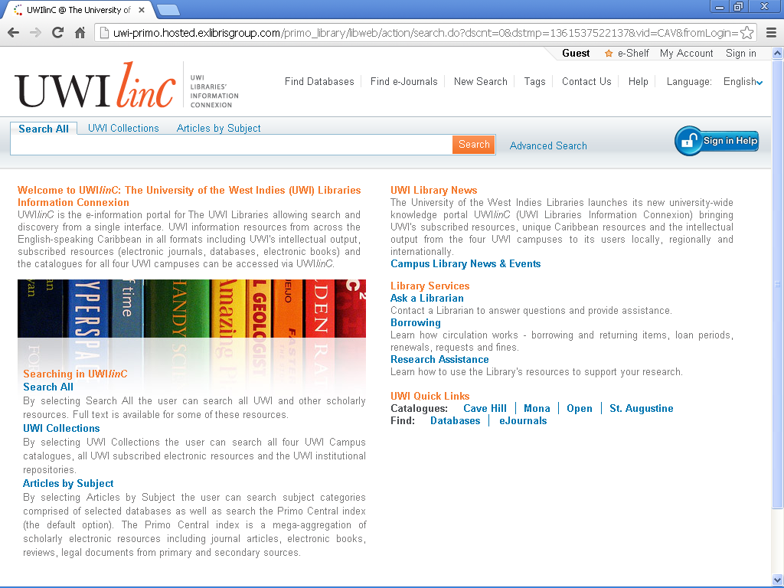

- Select “My Account”

- Select loans that you wish to renew

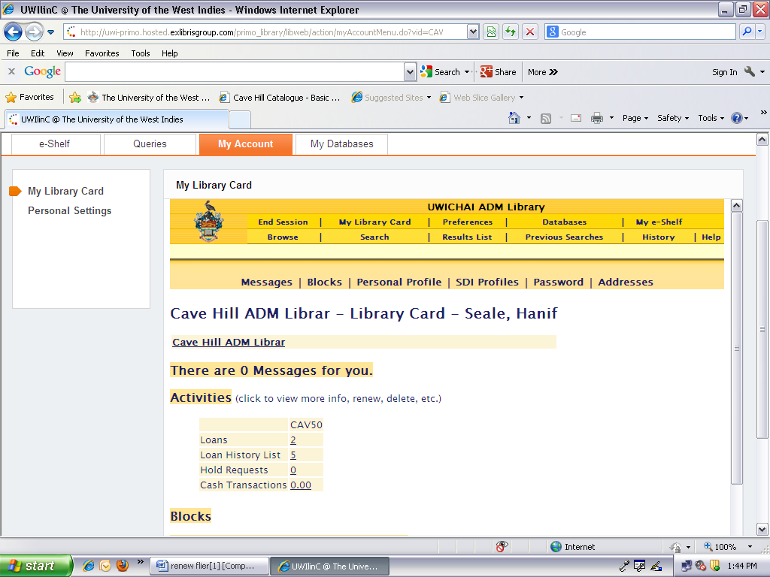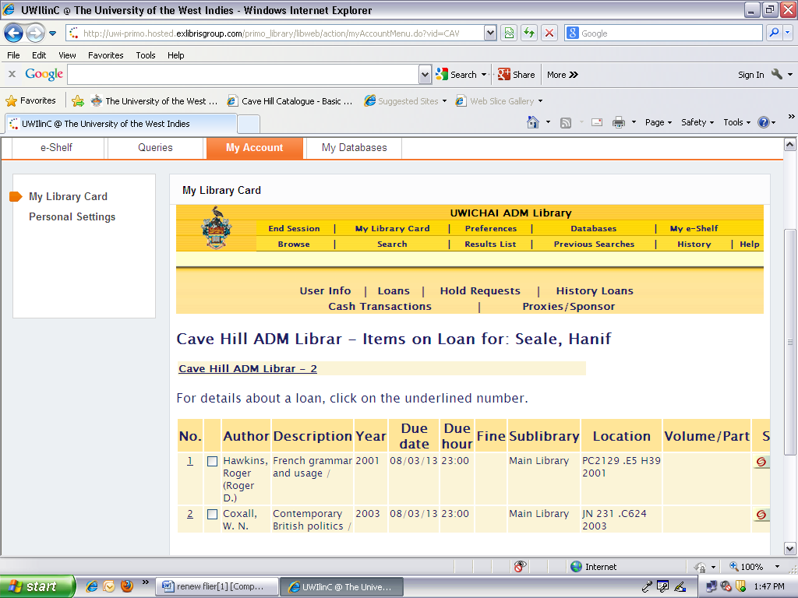
- Click “Renew” (Date automatically adjusts to new loan period)

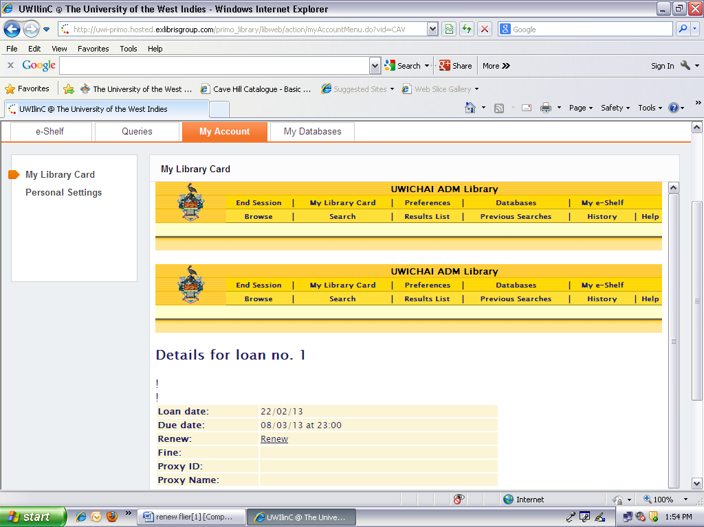

- Sign out

