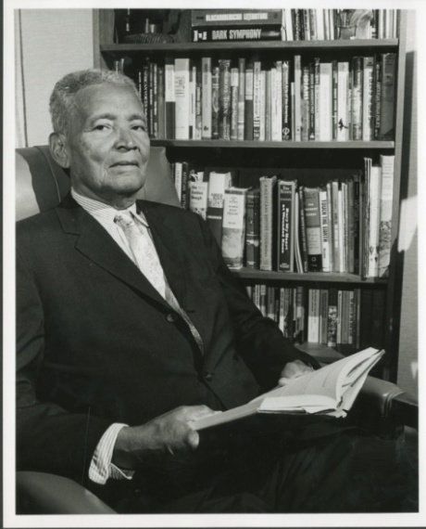
Richard Benjamin Moore (1893 -1978)
The Richard B. Moore Collection is a unique library of books and other printed items collected over a period of sixty years by bibliophile Richard B. Moore, a Black Barbadian writer, educator and activist. Mr. Moore resided in Harlem, New York from the period of the Harlem Renaissance to the Civil Rights era. The Collection documents important aspects of the Black experience during the early twentieth century and before. This collection is a unique resource not only for anyone interested in the cultural, intellectual and political history of the Black Atlantic World, but it is also of special importance to peoples of African descent throughout the world. The Collection reflects Richard B. Moore’s lifelong commitment to the causes of black consciousness and liberation, Caribbean nationalism, anti-colonialism and socialism, as well as his abiding interest in African heritage, culture and identity.

Adapted from: BARBADOS MEMORY OF THE WORLD NATIONAL REGISTER CITATIONS http://mowunescobarbados.org/page16.htm

The Richard B. Moore Collection is listed on the Barbados National Register of UNESCO’s Memory of the World Program.The Richard B. Moore Collection is located on level 2 of the Main Library in Room 204. Materials from this collection are available for reading room use only. Opening hours are weekdays 9.00 a.m. – 5.00p.m. For consultation outside of these hours patrons are required to call and make an appointment. To make an appointment and for further information, please contact:

Mr. Carlyle Best – carlyle.best@cavehill.uwi.edu or (246) 417-4769.
Mrs. Sandra Thomas – sandra.thomas@cavehill.uwi.edu or (246) 417-4959.

August 2012

